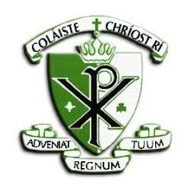

COLÁISTE CHRÍOST RÍ
CAPWELL ROAD
CORK
S.P.H.E. POLICY

Policy on Social Personal and Health Education

Coláiste Chríost Rí is an evolving Christian community committed to the ministry of Catholic Education. We cherish highly an ethos based on Gospel values. We pursue especially academic and sporting excellence within a unique Gaelic culture and tradition. We seek to promote full participation in all aspects of school life, bringing about the balanced development of each person. Our vision is Christian and Gaelic.

1. Rationale:

Our vision of education gives priority to the integration of the spiritual, intellectual, moral, physical and emotional development of the individual student. The work of the school is not an enterprise conducted in isolation but is very much influenced by the cultural and social mores of the time. The school is therefore challenged to address the cultural reality in which the students live and must aim to equip students with the skills necessary to cope in a world that is challenging and presents choices all the time.

In Coláiste Chríost Rí, we hope to develop persons who feel confident in responding to such choices. Such young people are responsible and inner directed and choose freely in response to an informed conscience.

The SPHE programmer in this school takes place within a Christian understanding of human development and sexuality and recognises the dignity of the individual. The programme addresses contemporary topics which are dealt with at a level appropriate to the age of the student and within a moral framework in keeping with the characteristic spirit of the school.

(A) Social Personal and Health Education

2. Aims:

The subject aims to develop students to be physically healthy, have good social skills and good mental health. This is achieved through a structured, cyclical programmer in accordance with the D.E.S. guidelines and the characteristic spirit of the school.

3. Subject Objectives:

- To enable students to develop skills for self-fulfillment and the living in communities.
- To promote self-esteem and self-confidence.
- To enable students to develop a framework for responsible decision making.
- To provide opportunities for reflection and discussion.
- To promote physical, mental and emotional health and well-being.
- To help young people understand and develop friendships and relationships
- To promote knowledge of and respect for reproduction
- To promote an understanding of sexuality
- To promote a positive attitude towards one’s own sexuality and in one’s relationships with others
- To enable young people to develop attitudes and values towards their sexuality in a moral, spiritual and social framework

4. Class Organisation and Timetabling:

SPHE is allocated one/two class period per week for all Junior Cycle students. Classes are organised in mixed ability groupings of an average of 30 students.

T.Y. SPHE will have one class per week

5th Years have a single class each week which may involves team teaching and allows for projects and guest speakers.

6th Years have a single class period of SPHE per week which involves team teaching and allows for projects and guest speakers.

In organising the learning environment, the teacher will be careful to create an atmosphere which respects the privacy of each individual student and treats each student with sensitivity and care. Active learning methods are used to ensure that students actively participate in their own learning.

Contemporary topics and issues which emerge in this class are dealt with at a level appropriate to the age of the student and within a moral framework, in keeping with the school ethos.

5. Planning for students with special needs:

We refer to NCCA guidelines and programmers can be modified to differentiate for the needs of the student.

6. Content:

Junior SPHE comprises four strands. These are re-visited each year as the students mature and their needs and abilities change. The emphasis is on building life skills and developing attitudes and values in relation to the areas explored.

Four Strands of SPHE:
- Minding Myself and Others
- Who Am I?
- Team Up (RSE)
- My Mental Health
These topics are followed systematically and built on from year to year in Junior Cycle.
The areas of learning explored in Senior Cycle build on Junior Cycle modules. Areas of learning, outlined below, are comprehensively covered over the duration (2/3 years) of Senior Cycle. Emphasis may be placed on particular topics in TY, 5th or 6th Year as appropriate.

- Gender Studies
- Mental Health
- Substance Use
- RSE
- Physical Activity and Nutrition

7. Methodologies:

The methodologies employed will include:

- Collaborative Learning (Group work / pair work)
- Group Discussions
- Oral Sharing
- Case Studies
- Brainstorming
- Role Play
- Artwork
- Narrative Expression
- Games – Icebreakers
- Games – Simulation
- Debates
- Project Work
- Personal Reflection
- Guest Speakers
- Didactic Teaching
- Team Teaching
- Active Learning, e.g. Walking Debates
- Experiential Learning
- Question Box
- ICT
- Film

In the light of the advice contained in Circular 0023/2010, the following approaches will be avoided when teaching SPHE in Coláiste Chríost Rí

- Scare tactics
- Sensationalist approaches
- Testimonials
- Information only interventions
- Information that is not age appropriate
- Once-off/short-term interventions
- Normalising young people’s risky behaviour

Junior Cycle Wellbeing Indicators

The Junior Cycle Wellbeing Guidelines 2017 note that schools have a central role to play in supporting and promoting students’ learning about wellbeing and for wellbeing. Students learn about wellbeing through specific areas of the curriculum and various wellbeing events and initiatives that are organised to develop awareness, knowledge and skills about wellbeing. They learn for wellbeing when their whole experience of school life including all the day-to-day interactions, both within and beyond the classroom, are respectful and caring. Thinking about learning for wellbeing requires that we consider not only what students learn but also how they learn it. Learning for wellbeing can be nurtured in all subjects and by all teachers.
The Indicators of Wellbeing are central to Wellbeing in junior cycle. The indicators make what is important explicit for students, teachers, parents and the wider school community. Each indicator has a small number of descriptors.

.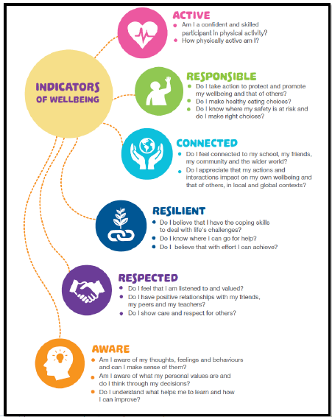

The indicators and their descriptors can be used in several ways:
- to review current provision for learning in wellbeing
- to plan teaching and learning within a school’s Wellbeing programme
- to plan conversations about how the school’s Wellbeing programme might best support young people’s wellbeing and well-becoming with stakeholders including students, parents and teachers
- to scaffold conversations with students about learning in the Wellbeing programme
- to frame the student’s self-assessment about their learning in Wellbeing
- to report on learning in Wellbeing.

SPHE provides opportunities for teaching and learning directly related to health and wellbeing. Through the use of experiential methodologies, including group work, SPHE aims to develop students’ positive sense of themselves and their physical, social, emotional and spiritual health and wellbeing. It also aims to build the student’s capacity to develop and maintain healthy relationships. Through studying aspects of SPHE, students have time to focus on developing personal and social skills including self-management, communication, coping and problem-solving.

The Junior Cycle Statements of Learning
The Statements of Learning are included on the next page. The SPHE Department has a role in supporting students to meet some of the Statements of Learning. We are working together and with the Principal towards identifying how we can contribute to these. This work will be ongoing across this and future school years.

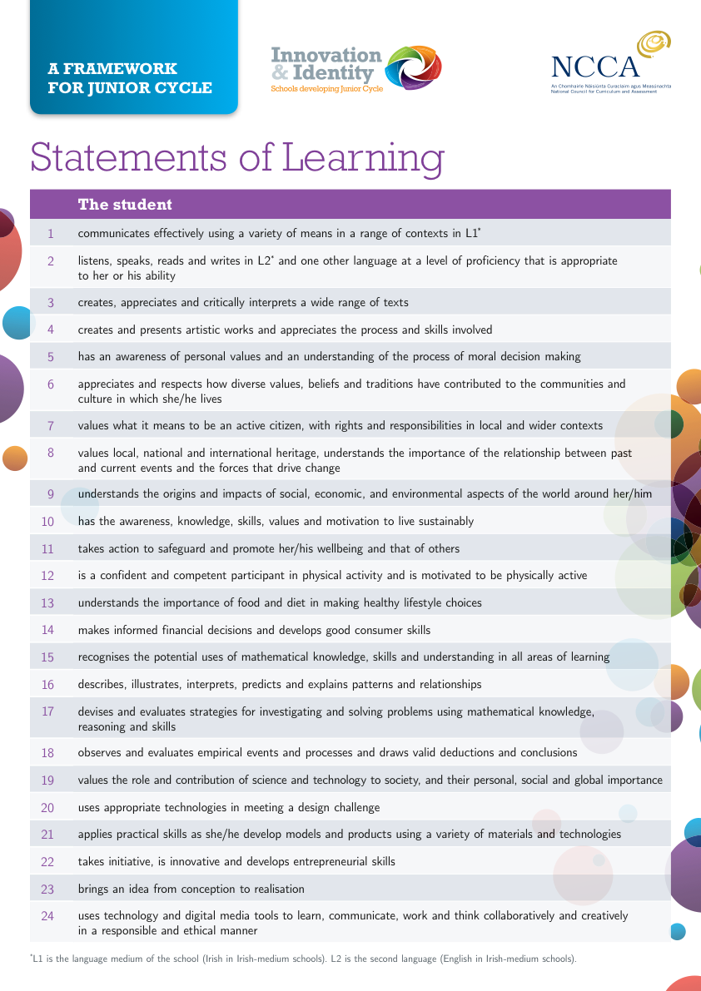

How the Wellbeing indicators link to the Statements of Learning and the Staying Well Key Skill
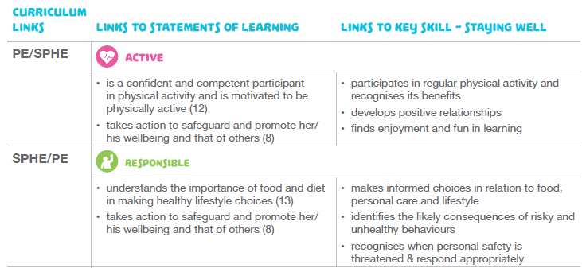
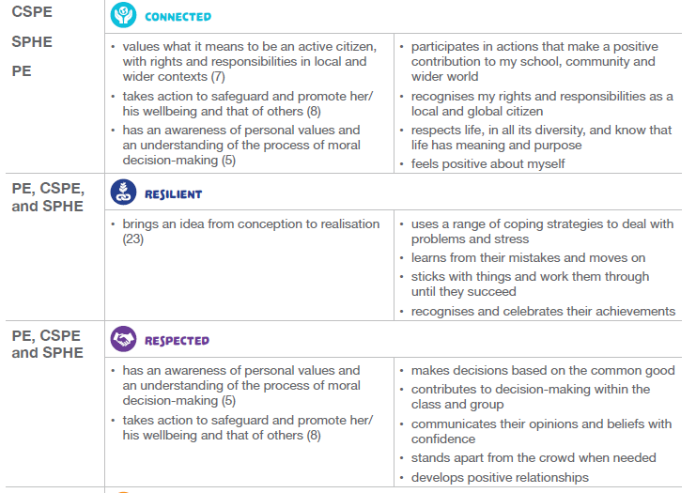
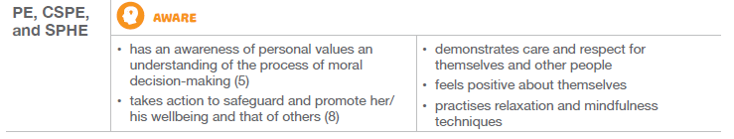

Key Skills in Junior Cycle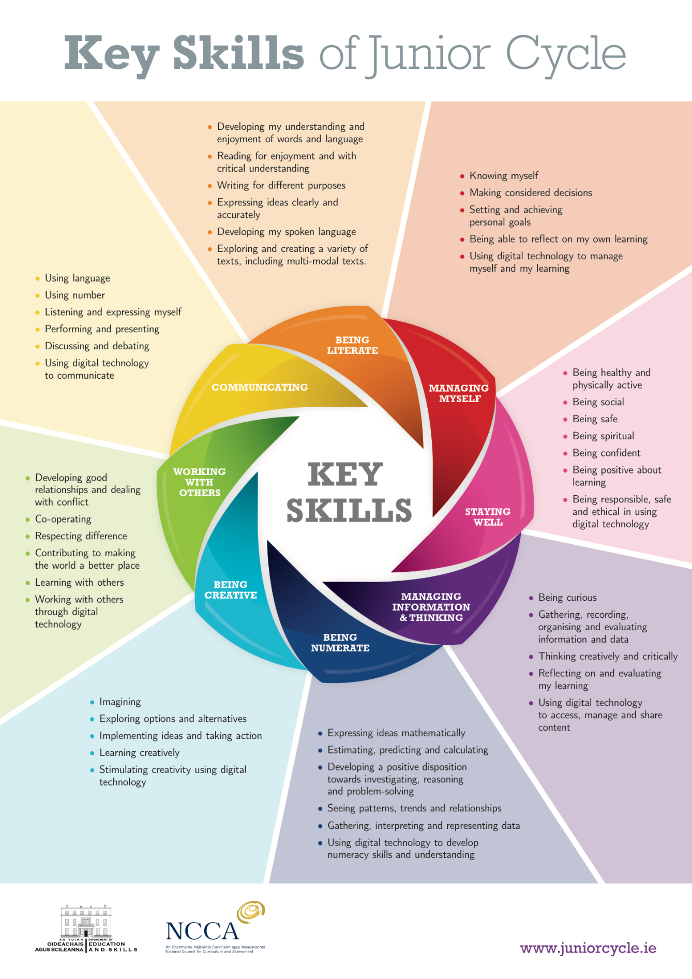

Key Skill Elements Relating to SPHE
The examples below identify some of the elements that are related to learning activities in SPHE. Teachers can also build many of the other elements of key skills into their classroom planning. The eight key skills are set out in detail in Key Skills of Junior Cycle.
Key Skill | Key skill element | Student learning activity
Being Creative | Exploring options and alternatives | Students explore and evaluate options and alternatives in the context of decisions they make. They record and communicate their learning in creative ways.
Being literate | Expressing ideas clearly and accurately | Students learn to articulate their thoughts and feelings clearly and respectfully through group work, role-play and reflections, and by exploring and discussing scenarios and case studies.
Being numerate | Gathering, interpreting and representing data | Students gather information through questionnaires, surveys and personal records and present their findings in graphic form to different audiences
Communicating | Listening and expressing myself | Students learn to express themselves clearly and respectfully, to ask for help, to listen to other peoples' viewpoints and discuss ideas and opinions.
Managing information and thinking | Gathering, recording, organising and evaluating information | Students become familiar with how and where they can access information and support to maintain their physical and mental health in a holistic way.
Managing myself | Knowing myself | Students learn more about themselves as they engage in decision-making activities and goal setting. They learn to be flexible, to organise themselves and their studies, to plan to achieve their goals and to develop a sense of balance in their lives.
Staying well | Being healthy and physically active | Students learn about taking responsibility for their wellbeing & relationships. They also learn how to include a balanced diet, physical activity and relaxation as part of a healthy lifestyle.
Working with others | Respecting difference | Students learn about group processes and how group membership can affect an individual’s thinking and behaviour. They develop greater empathy as they learn about other peoples’ perspectives and develop skills for relating effectively to others.

8. Confidentiality:

At the beginning of each academic year and frequently during the year, students are informed that complete confidentiality cannot be guaranteed. Information may have to be passed on at the discretion of the SPHE teacher to the Designated Liaison Person (Principal).

9. Resources and accommodation for SPHE:

A wide range of resources can be found on the SPHE Resource folder. Also, SPHE teachers have access to the SPHE folder on the server where e-resources, power points, activities etc are available. Resources are updated every year. An appropriate budget is made available by school management each year to cover the cost of the department’s requirements.. The library facilitates team teaching, active learning methodologies and is the ideal forum for guest speakers, as it allows for accessibility for all students. This collaborative space is fully equipped with data projector, speakers and Wi-Fi, accommodating the needs of students, teachers and guests. The Prayer / reflection room, a particularly significant area of our school, is available to all SPHE teachers for meditation, relaxation etc.
All students have phones / IED’s which can be used in accordance with the school’s acceptable usage policy. This can be used for activities, e books, research and reflection.

Junior Cycle Text book

Health & Well Being Book 1,2 &3 Edco

Senior Cycle
B4Udecide.ie Department of Education & Science, Crisis Pregnancy
Programme and Health Service Executive

T.R.U.S.T. Department of Education & Science,
HSE
Crisis Pregnancy Agency

SPHE Resource materials for Department of Education & Science
Relationships Sexuality Education
Post Primary Senior Cycle

10. Cross-curricular links:

Links are made with the following departments:
- Religion re: RSE
- Biology re: RSE
- Art re: posters to highlight issues, e.g. substance abuse
- Physical Education

11. Staff development and subject development

SPHE staff members engage in professional development on an ongoing basis.
The SPHE team avails of online resources which aid them in keeping up to date with the SPHE curriculum. The teachers also meet and discuss ideas and share relevant resources and feedback from courses attended.

12. Visitors:

The school is informed in this regard by Circular 0023/2010, Social Personal and Health Education (SPHE) and Relationships and Sexuality Education (RSE), Best Practice Guidelines for Post-Primary Schools.

We recognise that visiting speakers/facilitators play a valuable role in supplementing, complementing and supporting our programme. Visitors/visiting groups are required to adhere to the following guidelines of good practice:

- All visitors to the school are required to identify themselves at the school office, and sign in.
- All visits will be planned in line with the relevant whole-school SPHE programmers.
- Visitors to the school will be made aware of the Child Protection policy, RSE policy and Substance Use policy as appropriate.
- Talks/ programmers delivered by outside agencies or speakers must be consistent with the ethos of Coáiste Chríost Rí and the SPHE/RSE programmes. All visits must be planned with school personnel.
- A teacher(s) must remain in the classroom with the students.
- All programmes and events delivered by visitors and external agencies must use appropriate, evidence-based methodologies with clear educational outcomes. Such programmers are best delivered by those specially qualified to work with young people for whom the programmers are designed.
- All programmes, talks, interventions and events should be evaluated by students and teachers in terms of subject matter, messages, structure, methodology and proposed learning outcomes.

13. Parents:

The school acknowledges the role of parents/guardians as the primary educators of their children. The program seeks to support parents in this challenging task. Parents are informed by letter at the beginning of the school year about the delivery of RSE in the second term. They are directed to the SPHE website and if they require further discussion/clarification this is accommodated by the school. Parents are also informed about the possibility of their son opting out of RSE, although this is discouraged by the school.

14. Assessment/Evaluation:

The assessment and evaluation takes place in SPHE through student reflection and self-evaluation, differentiated questioning of students, student generated questions, worksheets, discussion, oral feedback, quizzes, teacher observation and reflection.

15. Whole school support for SPHE:

Colaiste Chriost Rí is a health promoting school which supports the ideals of the SPHE programme. Some examples of this are:

- Healthy, nutritious lunches are available to students each day at a reasonable price.
- Sports programmes and fitness lessons are engaged in by a large number of students.
- The Meitheal Student Leadership programme helps develop social skills and community building between first years and the more senior students
- A Pastoral care team meets once per week to discuss particular students and design interventions to support their wellbeing.
- Each year group has a Year Head who monitors and tracks the holistic wellbeing and progress of the students in their year group.
- Anti-bullying policy, practices and pledge combine to prevent and tackle bullying behavior.
- The well being committee offers support and guidance to the whole school body. Initiatives are run throughout the year to support mental, emotional and physical wellbeing. These are developed by the student ambassadors based on needs or issues that arise throughout the year.
- Guidance provision supports students’ personal and academic development through self-evaluation and target setting, and emotional wellbeing through individual counseling appointments.

16. Other policies relevant to SPHE
Substance Abuse Policy
Anti – bullying Policy
ICT Policy
Critical Incident Policy
Child Protection Policy
RSE Policy

This policy was adopted by the Board of Management on _________________[date]
Signed: _________________________ Signed: __________________________
Chairperson of Board of Management Principal
Date: __________________________ Date: __________________________
Date of next review: ________________

